INSTRUCTION MANUAL
503 & 703
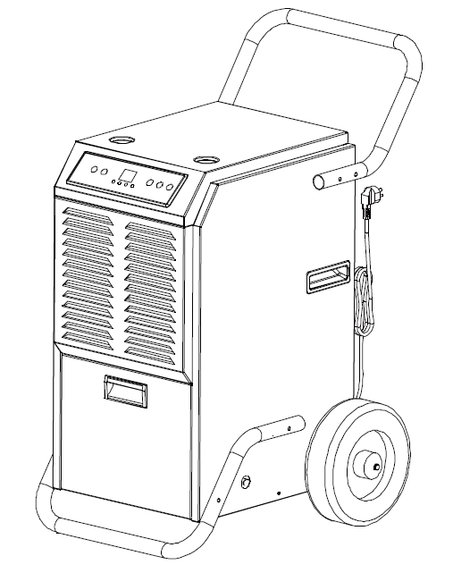

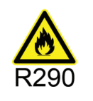


Please keep this manual for future reference!
Thank you for selecting our dehumidifiers. This manual details the proper use and maintenance of these dehumidifiers. Please take a few minutes to read this manual, and please keep it for further reference.

1.BEFORE YOU BEGIN
1.1 PRODUCT DESCRIPTION
The dehumidifier is used to remove excessive moisture from the air. The resulting reduction in relative humidity protects buildings and their contents from the adverse effects of excess humidity.
The environmentally friendly R290 is used as the refrigerant. R290 has no damaging influence on the ozone layer (ODP), a negligible greenhouse effect (GWP) and is available worldwide. Because of its efficient energy properties, R290 is highly suitable as a coolant for this application. Special precautions must be taken into consideration due to the coolant's high flammability.
1.2 SYMBOLS FROM THE UNIT AND USER MANUAL
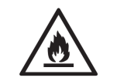  warning | This unit uses a flammable refrigerant.  If refrigerant leaks and comes in contact with fire or heating part, it will create harmful gas and there is risk of fire.
 | Read the USER MANUAL carefully before operation.
 | Further information is available in the USER MANUAL, SERVICE MANUAL, and the like.
 | Service personnel are required to carefully read the USER MANUAL and SERVICE MANUAL before operation.
THE FOLLOWING SHOULD ALWAYS BE OBSERVED FOR SAFETY
- This appliance is intended to be used by expert or trained users in shops, in light industry and on farms, or for commercial use by lay persons.
- This appliance can be used by children aged from 8 years and above and persons with reduced physical, sensory or mental capabilities or lack of experience and knowledge if they have been given supervision or instruction concerning use of the appliance in a safe way and understand the hazards involved. Children shall not play with the appliance. Cleaning and user maintenance shall not be made by children without supervision.
- The unit is designed only for use with R-290(propane) gas as the designated refrigerant.
- The refrigerant loop is sealed. Only a qualified technician should attempt to service!
- Do not discharge the refrigerant into the atmosphere.
- R-290 (propane) is flammable and heavier than air.
- It collects first in low areas but can be circulated by the fans.
- If propane gas is present or even suspected, do not allow untrained personnel to attempt to find the cause.
- The propane gas used in the unit has no odor.
- The lack of smell does not indicate a lack of escaped gas.
- If a leak is detected, immediately evacuate all persons from the store, ventilate the room and contact the local fire department to advise them that a propane leak has occurred.
- Do not let any persons back into the room until the qualified service technician has arrived and that technician advises that it is safe to return to the store.
- No open flames, cigarettes or other possible sources of ignition should be used inside or in the vicinity of the units.
- Component parts are designed for propane and non-incentive and non-sparking. Component parts shall only be replaced with identical repair parts.
FAILURE TO ABIDE BY THIS WARNING COULD RESULT IN AN EXPLOSION, DEATH, INJURY AND PROPERTY DAMAGE.
 PLEASE KEEP THE MACHINE UPRIGTH STAND FOR 24 HOURS BEFORE YOUR FIRST TIME USE .
PLEASE ALWAYS KEEP THE MACHINE UPRIGHT WHEN USING.
2.IMPORTANT SAFETY INSTRUCTIONS

Your safety is the most important thing we concerned!
2.1 OPERATIONALPRECAUTIONS
WARNING- to reduce the risk of fire, electric shock or injury to persons or property:
- If the supply cord is damaged, it must be replaced by the manufacturer, its service agent or similarly qualified persons in order to avoid a hazard.
- The A-weighted sound pressure level is below 45 dB.
- The appliance shall be disconnected from its power source during maintenance.
- Always operate the unit from a power source of equal voltage, frequency and rating as indicated on the product identification plate.
- Always use a power outlet that is grounded.
- Unplug the power cord when cleaning or when not in use.
- Do not operate with wet hands. Prevent water from spilling onto the unit.
- Do not immerse or expose the unit to rain, moisture or any other liquid.
- Do not leave the unit running unattended. Do not tilt or turn over the unit.
- Do not unplug while the unit is operating.
- Do not unplug by pulling on the power cord.
- Do not use an extension cord or an adapter plug.
- Do not put objects on the unit.
- Do not climb or sit on the unit.
- Do not insert fingers or other objects into the air outlet.
- Do not touch the air inlet or the aluminum fins of the unit.
- Do not operate the unit if it is dropped, damaged or showing signs of product malfunction.
- Do not clean the appliance with any chemicals.
- Ensure the unit is far away from fire, inflammable, or explosive objects.
- The unit shall be installed in accordance with national wiring regulations.
- Do not use means to accelerate the defrosting process or to clean, other than those recommended by the manufacture.
- The appliance shall be stored in a room without continuously operation sources (for example: open flames, an operating gas appliance or an operating electric heater).
- The appliance shall be stored so as to prevent mechanical damage from occurring.
- Do not piece or burn, even after use.
- Be aware that refrigerants may not contain an odour.
- Pipe-work shall be protected from physical damage and shall not be installed in an unventilated space, if that space is smaller than 12m².
- Compliance with national gas regulations shall be observed.
- Keep any required ventilation openings clear of obstruction.
- The appliance shall be stored in a well-ventilated area where the room size corresponds to the room area as specified for operation.
WARNING | Any person who is involved with working on or breaking into a refrigerant circuit should hold a current valid certificate from an industry-accredited assessment authority, which authorizes their competence to handle refrigerants safely in accordance with an industry, recognized assessment specification.
WARNING | Servicing shall only be performed as recommended by the equipment manufacturer. Maintenance and repair requiring the assistance of other skilled personnel shall be carried out under the supervision of the person competent in the use of flammable refrigerants.

  - SAFETY PRECAUTIONS ON SERVICING
Please follow these warnings when to undertake the following when servicing a dehumidifier with R290.
2.2.1 Checks to the area
Prior to beginning work on systems containing flammable refrigerants, safety checks are necessary to ensure that the risk of ignition is minimized. For repair to the refrigerating system, the following precautions shall be complied with prior to conducting work on the system.

2.2.2 Work procedure
Work shall be undertaken under a controlled procedure so as to minimize the risk of a flammable gas or vapor being present while the work is being performed.
2.2.3 General work area
All maintenance staff and others working in the local area shall be instructed on the nature of work being carried out. Work in confined spaces shall be avoided. The area around the workspace shall be sectioned off. Ensure that the conditions within the area have been made safe by control of flammable material.
2.2.4 Checking for presence of refrigerant
The area shall be checked with an appropriate refrigerant detector prior to and during work, to ensure the technician is aware of potentially flammable atmospheres. Ensure that the leak detection equipment being used is suitable for use with flammable refrigerants, i.e. no sparking, adequately sealed or intrinsically safe.
2.2.5 Presence of fire extinguisher
If any hot work is to be conducted on the refrigeration equipment or any associated parts, appropriate fire extinguishing equipment shall be available to hand. Have a dry powder orCO2 fire extinguisher adjacent to the charging area.
2.2.6 No ignition sources
No person carrying out work in relation to a refrigeration system which involves exposing any pipe work that contains or has contained flammable refrigerant shall use any sources of ignition in such a manner that it may lead to the risk of fire or explosion. All possible ignition sources, including cigarette smoking, should be kept sufficiently far away from the site of installation, repairing, removing and disposal, during which flammable refrigerant can possibly be released to the surrounding space. Prior to work taking place, the area around the equipment is to be surveyed to make sure that there are no flammable hazards or ignition risks. “No Smoking” signs shall be displayed.
2.2.7 Ventilated area
Ensure that the area is in the open or that it is adequately ventilated before breaking into the system or conducting any hot work. A degree of ventilation shall continue during the period that the work is carried out. The ventilation should safely disperse any released refrigerant and preferably expel it externally into the atmosphere.
2.2.8 Checks to the refrigeration equipment
Where electrical components are being changed, they shall be fit for the purpose and to the correct specification. At all times the manufacturer’s maintenance and service guidelines shall be followed. If in doubt consult the manufacturer’s technical department for assistance.
The following checks shall be applied to installations using flammable refrigerants:
– The charge size is in accordance with the room size within which the refrigerant containing parts are installed;
– The ventilation machinery and outlets are operating adequately and are not obstructed;
– If an indirect refrigerating circuit is being used, the secondary circuit shall be checked for the presence of refrigerant;
– Marking to the equipment continues to be visible and legible. Markings and signs that are illegible shall be corrected;
– refrigeration pipe or components are installed in a position where they are unlikely to be exposed to any substance which may corrode refrigerant containing components, unless the components are constructed of materials which are inherently resistant to being corroded or are suitably protected against being so corroded.
2.2.9 Checks to electrical devices
Repair and maintenance to electrical components shall include initial safety checks and component inspection procedures. If a fault exists that could compromise safety, then no electrical supply shall be connected to the circuit until it is satisfactorily dealt with. If the fault cannot be corrected immediately but it is necessary to continue operation, an adequate temporary solution shall be used. This shall be reported to the owner of the equipment so all parties are advised.
Initial safety checks shall include:
-those capacitors are discharged: this shall be done in a safe manner to avoid possibility of sparking;
-that there no live electrical components and wiring are exposed while charging, recovering or purging the system;
-that there is continuity of earth bonding.
3.FEATURES
- Large Capacity
- Movable and Easy to Store
- Built-in Auto Defrost System to protect key working components
- Adjustable Humidity
- Timed Operation
- Quiet Running
- Energy-saving design
4.SPECIFICATIONS
Model No. | OL50-B503E | OL70-B703E
Rated Voltage | AC220~240V | AC220~240V
Rated Frequency | 50Hz | 50Hz
Max.Rated Input Power | 725W(30℃,RH80%) | 915W(30℃,RH80%)
Water Tank Capacity | 5.5L | 5.5L
Sound Pressure Level | ≤52dB(A) | ≤52dB(A)
Refrigerant Charge | R290/120g | R290/185g

5. PRODUCT DRAWINGS

Front

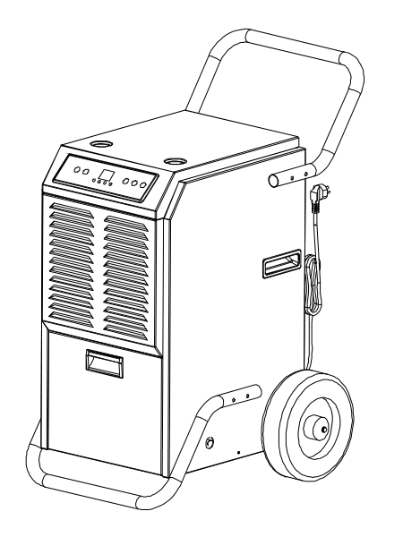
Big Wheel
Pushing Handle
Water tank cover
Air Inlet
Control panel

Back
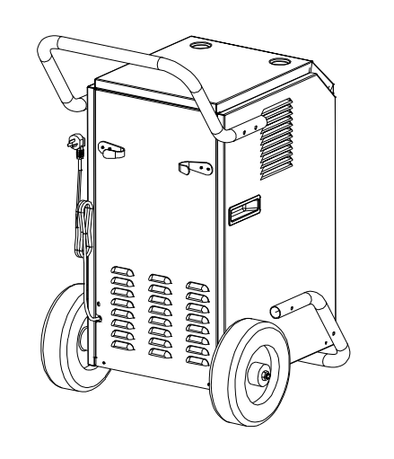
Radiator Grille
Built-in Handle

Support Frame

Air Outlet
Power cord
6. INSTALLATION
6.1 Handle and Support Frame Installation
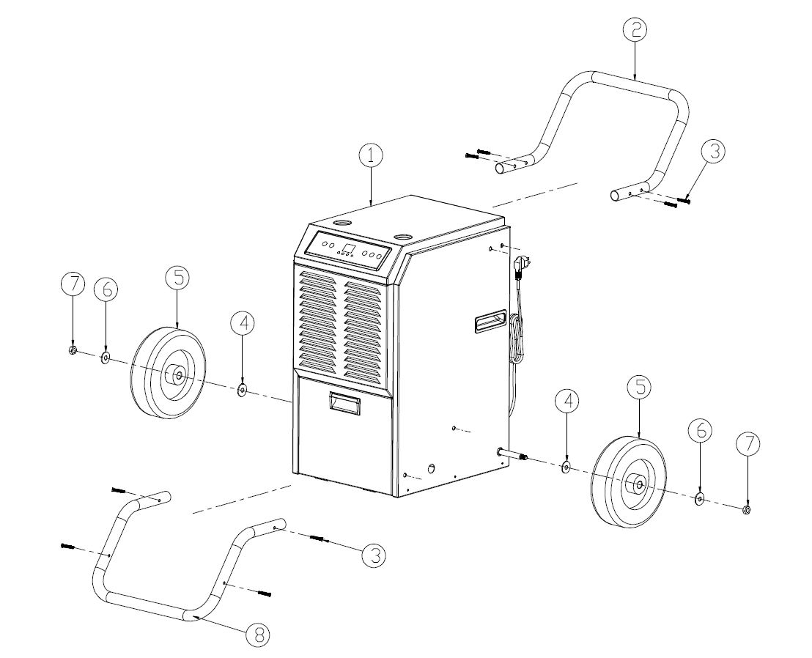
❶ Main Body ❷ Handle
❸ Stainless Steel Bolt ❹ Spacer
❺ Wheel ❻ Spacer
❼ Nut ❽ Support Frame
6.2 Drainage Installation
1) When the tank is full, the “FULL” light will turn on.
2) The unit will also make a buzzing sound. To stop this, press the power button to turn off the machine.
3) To clear the water tank, open the front panel to access the water tank.
4) Grab the handle of the water tank and pull it out horizontally.
5) After disposing of the water, replace the tank and close the front panel
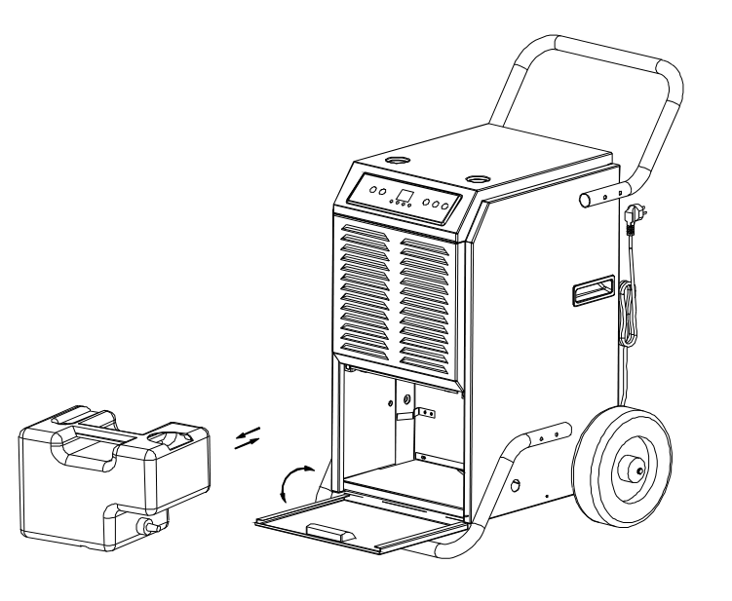
Continuous drainage
In extremely wet conditions, the tank may need frequent clearing. It can be set up for continuous drainage by doing the following:
- Open the front cover, remove the tank, and clear the water from the tank.
- Remove the plug and install the included drain pipe to the connector, direct the pipe to the desired area before operate the machine. See the pictures below.
- Make sure the water tank and drain pipe are not blocked, shut the front panel.
- When you do not use continuous drainage and turn to use water tank again, just use the plug to stop the water outflow from the connector.
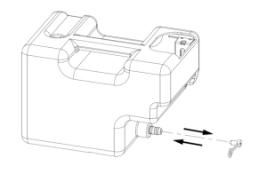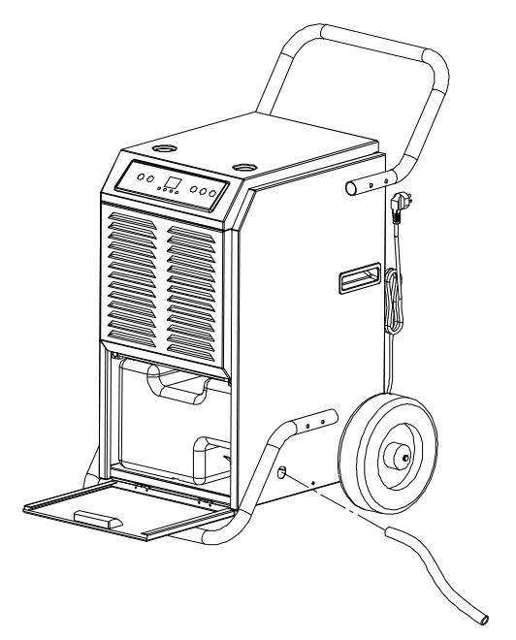

Continuous drainage pipe

- WARNING: Do not block the drainage hose. The end of the drainage pipe should not be higher than the outlet hole. If the drainage pipe end is higher than the outlet hole, water will not drain properly and could damage components of the unit.
7. MACHINE SETUP AND OPERATION
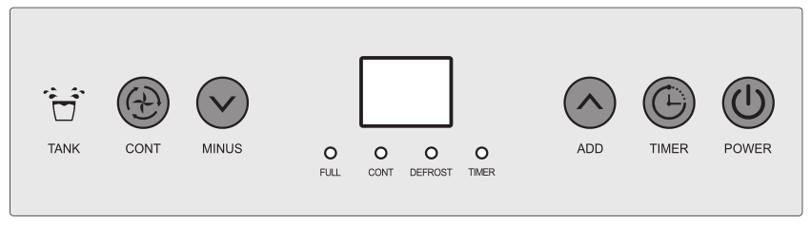
7.1 Button Function
(1) 
Press this button while on electric, screen light on, machine automatically goes to continuous mode, display screen shows environmental humidity, compressor on after fan run for 3 seconds; press this button again, compressor stops, display screen shows environmental humidity, machine goes to standby mode, fan will run for another minute and stop.
(2) 
Press this button while machine is on electric, until button light goes on, press “MINUS”“ADD”to set the time to start the machine, when the count down is over, fan and compressor start work.
Press this button button while machine is running, until the button light goes on, press “MINUS”“ADD”to set the time to stop the machine, when the count down is over, fan and compressor stop work.
Press and hold the TIMER & POWER button at the same time for 5 seconds and the current room temperature is shown on the display. After approx. 10 seconds, the current room humidity is displayed again.
(3) 
Increase the humidity by press this button at normal mode, humidity increase 5%RH with each press, buzzer rang each time with the press, press the button for 1 second can increase the humidity continuously; press this button to set the time after press “TIMER”.
(4) 
Decrease the humidity by press this button at normal mode, humidity decrease 5%RH with each press, buzzer rang each time with the press, press the button for 1 second can decrease the humidity continuously; press this button to set the time after press “TIMER”.
Note:
1) The default humidity is 50%RH, to increase and decrease as follow:
20%-25%--30%-35%-40%45%-50%-55%-60%-65%-70%-75%-80%-85%-90%
2) Environmental humidity and machine set humidity will decide the status of compressor and fan as follow:
Environmental humidity≥ machine set humidity+3% ,compressor and fan start running.
Environmental humidity＜machine set humidity+3%,compressor and fan stop running.
Press continue button at continuous mode, switch to normal dehumidification mode, set the humidity manually.
- 
Continuous mode---(display screen shows current humidity)machine keeps running, continuous mode light on, humidity set is invalid, time set is available. Press continuous mode to switch to normal mode, continuous mode light off, humidity set is operational.

7.2 Operation
1) 5 seconds after the water tank is full, alarm goes on, water tank light goes on red, buzzer rang 15time, compressor and fan stop, after empty the water tank, machine automatically switch to the previous mode, compressor will start after 3 minutes self-protect. Alarm will stop in 3 seconds after the water tank was emptied and put back, fan starts, compressor will start in 3 minutes.
- Compressor will not need 3 minutes for self-protect if it was the first time to start the machine, press “POWER” and power off; Power on, press “POWER”, compressor start immediately.
- The system has auto memory. When all the mode setting has been finished, if there is sudden power cut during operation, or the power jack slips out, the system may store the current status before the power is cut and enter the operation mode before power cut automatically after power is supplied.

7.3 Defrost Function
- Environmental temperature＜5℃, or environmental temperature >38℃, compressor and fan stop.
- Defrost requirement: Compressor running for 30 minutes, temperature sensor sense the temperature ≤-1℃,(last for 10 seconds), compressor stops, defrost starts, fan continues, defrost light on, when the pipe temperature goes to 5℃ or the defrost last for 15 minutes, defrost stops.
Note: during defrost, light won’t be off until the defrost is over.
8. ERROR
- “E1”: If the temperature sensor got failure, it will show “E1”. The system works in circle of dehumidification for 30 minutes and defrosting for 15 minutes. We should replace the failure temperature sensor with a new one.
- “E2”: If the humidity sensor got failure, it will show “E2”. The humidity adjusting button will not work. The system works in circle of dehumidification for 30 minutes and defrosting for 15 minutes. We should replace the failure humidity sensor with a new one.

The dehumidifier will not work when encounters the following situations:
1) The surrounding temperature is lower than 4℃.
2) The surrounding temperature is equal to or higher than 35℃.
3) The surrounding humidity is less than 20%.

9. MAINTENANCE
9.1 Clean the machine with a soft wet cloth.
9.2 Pull the louver on the front panel out to gain access to the filter.
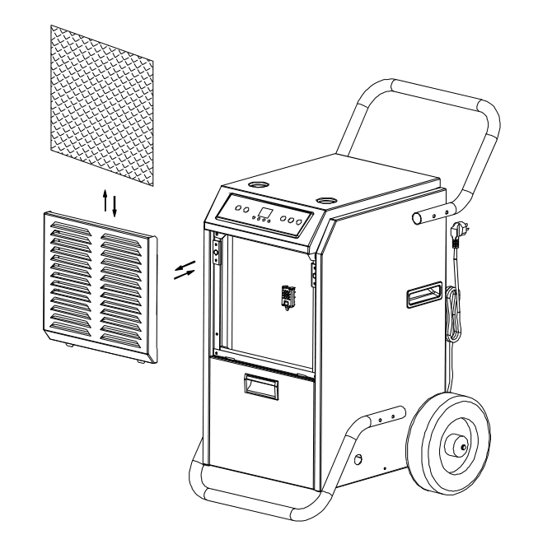
9.3 Remove the filter mesh out of the unit.
9.4 Use a clean rag to adsorb the surface dust on the filter mesh. If the filter is extremely dirty, use tap water to flush the filter. Fully dry the filter before putting it back into the air inlet fence. A clean filter will increase the machine’s capacity.

10. MACHINE STORAGE
If you don’t use the unit for an extended period of time, please store it per the following steps:
(1) Clean the filter mesh.
(2) ATTENTION: the evaporator inside the machine has to be dried out before the unit is packed to avoid component damage and molds. Unplug the unit and place it in a dry open area for days to dry it out. Another way to dry the unit is to set the humidity point more than 2% higher than the ambient humidity to force the fan to dry the evaporator for a couple of hours.
(3) Collect the power cord, bunch it, and hung it in the power cord pocket at the back of unit.
(4) Store in a clean, dry environment.
11.TROUBLE SHOOTING
Please confirm by after-sale service for the following conditions.
trouble | cause | solution
Machine does not run | Unit is not plugged in | Plug in the unit
Machine does not run | Room temperature under 5 degrees or above 35 degrees. | To protect the machine, use it only when ambient temperature is between 5 and 35 degrees.
Machine runs but does not dehumidify | When the humidity set point is 2% higher than ambient humidity. | Reset the humidity to a lower set point, or power off the machine if the humidity has satisfied you.
Reduced dehumidifier capacity | Filter mesh jammed | Clean the filter mesh according to manual
Reduced dehumidifier capacity | Air-in and/or Air-out louvers jammed. | Clear the blockage from Air-in and/or Air-out louvers.
No air inlet | Filter mesh or air-in louver jammed. | Clean filter according to instructions or clean the louver blockage
Loud Operation | Machine situated on an incline or decline slope | Move to flat ground
Loud Operation | Filter mesh jammed. | Clean filter mesh according to instructions
Cautions: Switch off the unit and unplug it immediately if anything abnormal happens. Then contact a qualified electrician.
Do not dispose of electrical appliances as unsorted municipal waste, use separate collection facilities.

Contact you local government for information regarding the collection systems available.

